Imagineers Classroom

Workout

P.B.L. and S.T.E.M. Lessons
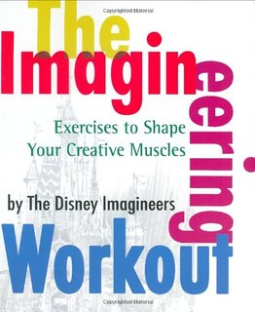

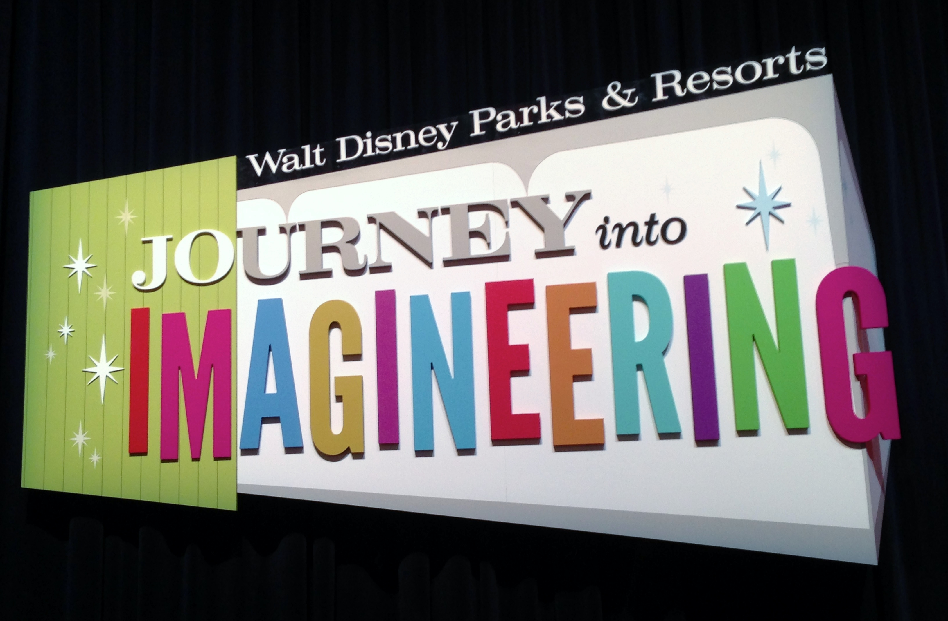

Unofficial Training Guide

for

"Disney EdMagineering Educators"
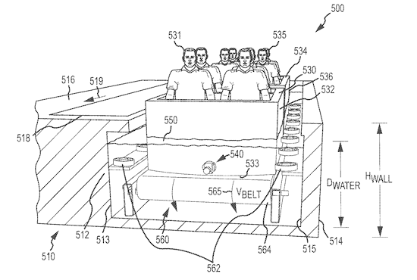

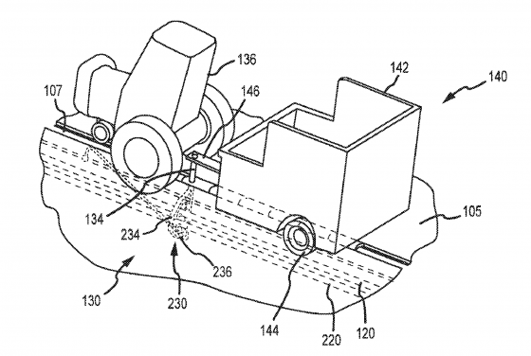

Howie DiBlasi, Ph.D.

UPDATED and Revised: Version WL1.26
Concept sketch-provided courtesy of DisneyPark Blueprints
S.T.E.M - S.T.E.A.M - P.B.L. - I.B.L.

8. Scoring Rubric for Oral Presentations:

Category | Scoring Criteria | Total Points | Score
Organization  (15 points) | The type of presentation is appropriate for the topic and audience. | 5
Organization  (15 points) | Information is presented in a logical sequence. | 5
Organization  (15 points) | Presentation appropriately cites requisite number of references. | 5
Content  (45 points) | Introduction is attention-getting, lays out the problem well, and establishes a framework for the rest of the presentation. | 5
Content  (45 points) | Technical terms are well-defined in language appropriate for the target audience. | 5
Content  (45 points) | Presentation contains accurate information. | 10
Content  (45 points) | Material included is relevant to the overall message/purpose. | 10
Content  (45 points) | Appropriate amount of material is prepared, and points made reflect well their relative importance. | 10
Content  (45 points) | There is an obvious conclusion summarizing the presentation. | 5
Attraction  ( 150 points) | Team Name  – Introduce each team member on the team-providing their name and job | 5
 | Name of the attraction | 3
 | Audience - Age Group or who is the attraction for | 3
 | Names the Type of attraction | 3
 | Back story of the attraction | 10
 | One sentence: Opening line in the attraction guide | 3
 | One sentence: Closing line in the attraction guide | 5
 | How do the guests enter the attraction?  How did you "PLUS" the attraction? | 10
 | Story behind the queue | 15
 | Weinie | 5
 | Interactive queue | 10
 | Four paragraphs that describe the attraction in detail | 20
 | What role does the "Annimatronic" figures play in the attraction | 10
 | Sketches / Drawings / Model renderings | 10
 | 3-D Drawing of the attraction | 10
 | Audio/Music used for or during the presentation | 10
 | Video used during presentation:BONUS Points if USED | 10
 | Slides or Slide or visuals used during the presentation | 10
Presentation  (40 points) | Speaker maintains good eye contact with the audience and is  Appropriately animated (e.g., gestures, moving around, etc.). | 5
Presentation  (40 points) | Speaker uses a clear, audible voice. | 5
Presentation  (40 points) | Delivery is poised, controlled, and smooth. | 5
Presentation  (40 points) | Good language skills and pronunciation are used. | 5
Presentation  (40 points) | Visual aids are well prepared, informative, effective, and not distracting. | 5
Presentation  (40 points) | Length of presentation is within the assigned time limits. FIVE MIN | 5
Presentation  (40 points) | Information was well communicated. | 10
Total Score | Total Points | 250

11. Organizing a Team
Individual Job Responsibilities - You will be assigned a grade based on work at your chosen job. Although this is a group project, you will receive a grade for your work only. You may also earn bonus points based on how well your piece fits together with the other members of the group and how well you work together in your group.

Creative Project Manager (CPM) Disney Resource
Imagineer Researcher
Computer-Skills expert/Presentations Story Teller
Architect's/ Model Builder Mind Mapper
Art Designer Engineer
PR Director/Presentation Responsibilities Audio-Music editor
Recorder-Note taker

Creative Project Manager  Responsible for ensuring that the Project Team completes the project. communication, including status reporting, risk management, escalation of issues that cannot be resolved in the team, and, in general, making sure the project is delivered in budget, on schedule, and within scope. Oversee journals of each job. | Disney Resource  If possible this should be an individual that has been to Disney World at least 3 times and is familiar with the 4 parks. They will provide resources and background information for the team members.
Researcher - Google/search expert  Evidence of research and writing skills  Journal entries  -sketches, pictures, and a daily log  Internet research documentation  Use of Publisher program to create magazine cover  -thesis statement portrayed on cover  -Search Web for "Patent Data" | Mind Mapper - Brainstorming  Brainstorming is a group or individual creativity technique by which efforts are made to find a conclusion for a specific problem by gathering a list of ideas spontaneously contributed by its member(s).  Desired qualities are:  Defer judgment,  Reach for quantity
Computer-Skills expert/Presentations  Knowledge of MAC/PC software  Knowledge of Presentation software and telling the story to make a "Persuasive Presentation"  Editing software skills | Art Designer  -create/develop specific parts of an art piece or scene  -overall visual appearance and how it communicates visually  -stimulates moods, features, appeals to a target audience  -translate desired moods, messages, concepts, and ideas into imagery.  -imagining what the finished piece or scene might look like
Story Teller  Know your audience  Wear your guest's shoes  Organize the flow of people and ideas  Create a weenie  Communicate with visual literacy  Avoid overload  For every ounce of treatment, provide a ton of fun | Engineer's Responsibilities  Evidence of technical writing skills  -sketches, pictures, and a daily log  Technical report to include:  -track design description ;research on design elements & on materials; mathematical configurations ;safety measures ;forces  Special effects and projections. & Annimatronics  Correspondence with an Disney expert via: interview, email, or online
Architect's/ Model Builder  Evidence of descriptive writing  Journal entries  -sketches or pictures, and a daily log  Scaled continuous side and top view  -correct labels for speed, distance, time, and forces  Realistic rendition of attraction including:  -outside environment-theme-topography  -design of track and car  Slope of first drop and angle of decent  - Create model to scale | Audio-Music editor  Locate audio file on the Web  Create background music for the themed attraction & final presentation.  Knowledge of audio editing software  Records audio data from various devices;  Sound editing functions include cut, copy, paste, delete, insert, silence, trim and more;  Audio effects include, amplify, normalize, equalizer, envelope, reverb, echo, reverse, sample rate conversion and much more; Capable of using CD ripper/Burner;
PR Director/Presentation Responsibilities  Evidence of persuasive writing skills  Journal entries -sketches, pictures, and a daily log  Presentation for the group-multimedia presentation  Presentation should include:  -unique features –theme-story-weinie  -highlight coaster specs & car design  -some information from each of the other jobs | Recorder-Note taker  Transcribe conversations as meetings take place  recording information captured from another source.  Familiar with several apps for MAC or PC to assist in the note taking/recording process  Organizational and be able to process main ideas

12. As the educational leader you will need to select Creative Project Managers

Questions to ask the class to select your Creative Project managers: If possible select the number of Creative Project Managers based on your - class size. Move them to the front of the class
1. Who has been to Walt Disney World or Disneyland Park 8-10 times
2. Who has been to Walt Disney World or Disneyland Park 5-7 times
3. Who has been to Walt Disney World or Disneyland Park 3-4 times
4. Who has been to Walt Disney World or Disneyland Park 2 times

Ask the following- If you need additional information from the potential project managers: NO more than 30 seconds for each answer below
1. Tell us who you are and what you do
2. Tell us about your experience in leadership and how to delegate jobs to individuals and solve problems
3. What is your favorite Disney Park and Why? IE EPCOT or Animal Kingdom?
4. What is your favorite Disney Park LAND and Why?
5. What is your favorite Disney Movie and why?
6. What is you favorite Disney Themed attraction and Why?
7. Explain in 30 seconds why Disney creates a story to go with the attraction
8. My favorite Disney character is........
9. I love Disney because.....

13. Skills Database – For remaining participants/students
-I have the following skills:
You need to hire me because......
___ I have experience in WRITING - Stories; Visual Literacy; Blogs
___ I can create and build things from cardboard
___ Give me paint, cardboard, sticks and pipe cleaners and I will CREATE a ___
___ I have experience in creating Digital Stories and in Visual Literacy
___ I have experience in creating Animation/Videos
___ I have experience in creating STOP-Motion Videos & Apps/Tools
___ I have experience in creating videos that tell a story
___ I know how to create a slide show in an application -OTHER that PowerPoint
___ I know how to EDIT and RECORD with Audacity
___ I know how to search with 3 DIFFERENT search engines to find IMAGES
___ I know how to SEARCH and Locate-specific You Tube videos
___ I know how to SEARCH and Locate-specific Disney songs on the Web
___ I am an "Artist"-I can use Google SketchUp;/TinkerCAD/AutoCAD/3D Draw
___ I have experience in building “Scale Models”
___ I know how to and like to “tinker” with things
___ I understand “High Tech stuff”
___ I play a musical instrument
___ I have over 150 songs and music on my iPod
___ I am an expert in ________________________

My top skill is: _______________________

My second best skill is ___________________

My third best skill is _____________________

You should select me to be on YOUR team because

16. Prep List: 5 Minute FINAL Presentation List & Notes
Items depends if you are doing 1 day-5 days or 10 days or semester project (modify as needed)
Check List - Who does what? >>>> Major components to include the following:
- Name your DESIGN group-Team Name - Introduce member’s names on the team and their job
- Name of the attraction
- Location of the Attraction- Park and Land
- Type of attraction –Ride vehicle-Boat or water-Track-Dark etc
- Audience - Age Group or who is the attraction for
- Story and "Theme"- One sentence open line in the attraction :
Sample: “Careen through the Himalayan Mountains on a speeding train while avoiding the clutches of the mythic Abominable Snowman.”
- What is the Back story
- What is your "Weenie"? …which says to people 'come this way.You have to have something the beckons them to 'walk this way.'"
- Queue and description of the ride/attraction
- Four paragraphs that describe the attraction in detail
- How do the guests enter the attraction?
- Interactive queue – Do you have one? If so-what is it and how does it work?
- One 8 x 10 Graphic Flyer - used to attract the guests to your NEW attraction- PR/magazine that
will market your attraction/ride to the general public.
- Can & should we included a sketch, drawing or a 3-D drawing of the attraction (Your choice
- Sketch or drawing of the FLOW of the attraction-Sue the DOC Camera to display
- A Model / Mock-up ( you can substitute web images
- How did you "PLUS" the attraction? Describe it!
- Do "Animatronics" figures play in the attraction? What are they? – Where are they located?
- Audio/Music for the attraction
- Research on the patent that applies
- A technical report highlighting specific features of the ride
- Persuasive techniques that “sell” your design to the committee/authentic audience.
- Audio/Music for the attraction-presentation ( background music is fine
- Will we use a video in the presentation?
- One FINAL sentence closing line in the attraction guide-
SAMPLE: “Or will the Yeti claim another victim?”
- Assignment presentation for each member of the team - Who Does What?
1. 2. 3.
4. 5. 6.
7. 8. 9.
10.

17. Pre-Assessment : Accessing prior knowledge
What Do I Know and Not Know About Disney Theme Parks

Activities: Students/participants are asked to think about their past experiences and understanding of Disney Theme Park Attractions.

Name the Six Disney Parks and their locations around the WORLD
1.
2.
3.
4.
5.
6.

Knowing what I know and what I don't know: ( PLAY 26 questions
- Define the term 'Amusement Park"
- Define the term 'Theme Park"
- The difference between a theme park and an amusement park is ______
- Describe the difference between Walt Disney World and Disneyland
- Name the Theme parks at Walt Disney World
- Name the lands at "Disneyland"
- Name ten type of attractions/rides (an example would be a rail or gravity ride )
- What is a Disney "Imagineer" and what do they do?
- Why is " Storytelling " a big part of a "Themed" attraction?
- What is a "Backstory"
- Name an attraction and tell about the "Backstory"
- What is the "Queue"
- What is an "Interactive Queue?"
- What does it mean to "PLUS" the attraction?
- What is a "Wenie" in Disney terms?
- Describe what "Animatronics" is
- What role does "Animatronics" play in attractions ?
- Give an example of a "Animatronics" figure and the attraction it is in
- Describe what "Audio-Animatronics" is
- Describe a: " Audio-Animatronics" figure and the attraction it is in
- Give an example of a: "DARK RIDE" at a Disney Park
- Give an example of a: "BOAT RIDE" at a Disney Park
- Give an example of a: "GRAVITY RIDE" at a Disney Park
- Give an example of a: "SIMULATOR RIDE" at a Disney Park
- What is Blue Sky?

30. Create the three critical pieces of you "Themed Attraction"

Example: WONDERLAND by Eva
This ride dives into the rich, imaginative world of Lewis Carroll’s Wonderland and the nonsensical characters that inhabit it.

BACKSTORY
The eccentric, yet earnest Seeker has found what he believes to be the journal of Lewis Carroll, and has been dissecting it word by word ever since. To the logical, untrained eye the journal reads mostly as nonsensical scribblings. But the Seeker knows in his heart there is truth behind the madness. He is determined to find the ‘Wonderland’ Carroll describes and prove its existence to the world!

QUEUE
The Seekers is looking for a team to find wonderland with him. In the queue, the guests will be introduced to the backstory and all the while leading up to the Seeker’s laboratory. Once the guests arrive at the pre-show, they meet the Seeker where he congratulates as being specially selected for this mission! He has spent years developing an invention that will take you deep into Wonderland itself, the only trouble is he needs the right team to pilot the machine while he monitors the controls remotely. The guests are the only people mad enough to be trusted for such an important quest! With no time to delay, he urges the guests to board the machine so he can finally set it on its magical course.

RIDE
The ride itself will be a combination of classic dark ride storytelling and modern thrill ride elements. The ride vehicle will be fast moving, with sharp turns and level changes, but not as extreme as a gravity and iron ride so the story can be appreciated and understood.. The ride story will be geared more towards the elements of the Tim Burton film than the classic tale experienced in the current Alice in Wonderland dark ride. Additional this ride will not feature Alice as the main character but rather focus on Wonderland itself, from Lewis Carroll’s perspective. By doing this, the hope is to attract a wider audience base, specifically more mature guests.

34. Disney - Ultimate Attraction Guide – Sample below
>>> Assignment : Develop an attraction concept.
This blue-sky phase is fun, because reality hasn't yet intruded on our plans

Expedition Everest - Legend of the Forbidden Mountain®
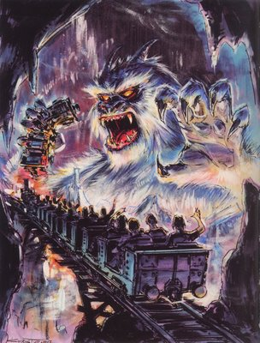
(1)
Careen through the Himalayan mountains on a speeding train while avoiding the clutches of the mythic Abominable Snowman.

(2)
Beware the Legend - Folklore has it that a fierce guardian monster protects the Forbidden Mountain.
For years, the Royal Anandapur Tea Company shipped its tea by train through the Forbidden Mountain pass. After a series of mysterious accidents were blamed on the dreaded Yeti monster, the railroad closed. Today, the railway is operating again, thanks to a group of local entrepreneurs—Himalayan Escapes, Tours and Expeditions— who offer curious travelers transportation to the base camp on the scenic mountain.
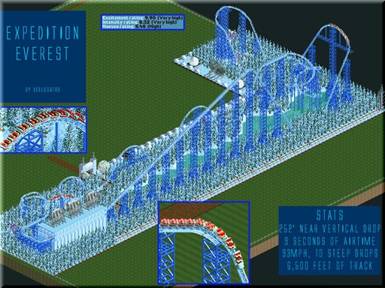
Yet there are some who believe the legend to be true and that the Yeti will do everything in its power to protect the sacred realm of the Himalayas. Visitors beware.

(3)
Climb the Mountain - Embark on a thrilling expedition through the icy peaks of the Himalayas.

Venture inside a Tibetan-style stone structure at the foot of towering Mt. Everest and make your way past the booking office of Himalayan Escapes – Tours and Expeditions. Wander past a small temple and a cozy general store before exploring a museum dedicated to the study of the Yeti, the mysterious snow monster said to inhabit the Himalayas.

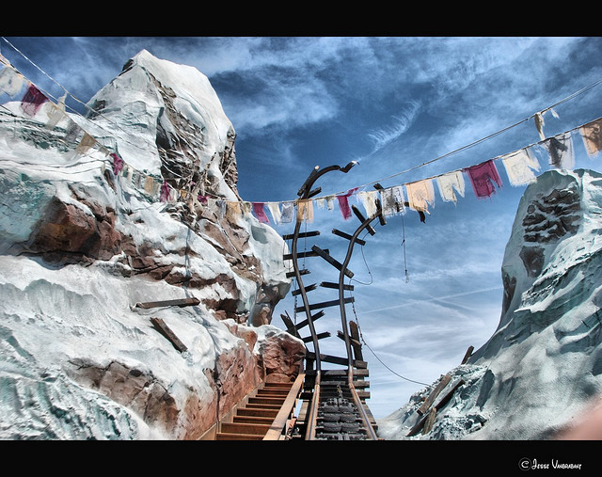
(4)
The Adventure Begins - Board a weather-beaten train and ascend a series of rolling hills overlooking a serene green forest. Climb a steep incline and navigate through a ceremonial stone tunnel before reaching the summit. Once at the “top of the world,” hold on tight as you pick up speed and race inside the dreaded mountain.

(5)
An Unexpected Encounter - Without warning, your train screeches to a halt: A broken and twisted track appears in front of you. Brace yourself as your train unpredictably begins to race backward into the darkened mountain, furiously swooping up into a double-looping turn. Inside the windswept passage, the shadowy figure of a growling creature can be seen on a cavern wall. It is the Yeti—the legend is real.
Hurl 80 feet down the base of the cursed mountain and swoop in and out of murky caves and along jagged rocky ledges as you race to escape the dreaded monster before he catches up with you.
Will you make it back to civilization safely?

(6)
Or will the Yeti claim another victim?

37. Develop Your "PITCH" SAMPLE Below

The Wildest Ride in the Wilderness
Dash in and out of desert caverns and rumble through a haunted mine aboard a speeding train.
Amid rugged bedrock and desert cactus, venture inside a nearly 200-foot mountain to the Big Thunder Mining Company, established in the early days of America’s Gold Rush. Traipse down into an abandoned mine shaft and discover a mysterious 5-car locomotive waiting to take you on a journey inside an abandoned shaft.

Hang Onto Your Hats!
As you begin your journey into the darkness of the tunnel, the train’s wheels chug back and forth across a rickety track. Swoop around turns and dip and drop into canyons and caves, darting through the ghost town of Tumbleweed.
Peel under a booming waterfall, past rock formations, and dodge a rumbling boulder from an inexplicable landslide. Along your adventure, glimpse the remnants of a flash flood and behold a bevy of local critters—including bats, opossum and a goat—before hastily making your way back to the safety of the railroad station.

A Trans-Dimensional Joyride to the Dinosaur Age
Travel back in time on a perilous race to rescue an Iguanadon before the meteor that wiped out the dinosaurs strikes.
Step inside the halls of The Dino Institute, a one-time secret research facility and museum that is home to real fossils dating back to when dinosaurs walked the earth. During narration provided by Bill Nye the Science Guy, stroll past prehistoric exhibits and behold the colossal skeleton of the carnivorous Carnotaurus, one of history’s most feared dinosaurs.

A Secret Mission
Make your way into the research control center and watch an informative video about your adventure into the primeval past aboard the CTX Time Rover—your vehicle for the trip back in time.
The presentation takes a turn when you're recruited to rescue a mild-mannered Iguanodon from extinction and return back to the present with the 3.5-ton dinosaur.
There’s just one problem: The date you're being transported to is around the same time that a giant meteor hit the Earth and caused the extinction of the dinosaurs.
Can you find the Iguanodon and return back to the present in time to avoid the cataclysmic event?

Blast to the Past!
Board a sturdy, 12-seat Time Rover and race through a darkened forest in search of the tagged dinosaur.
Experience the world as it existed 65 million years ago! Speed past a spiky Styracosaurus grappling with a nearby tree. Brace yourself as you careen through unpredictable hairpin turns, a ragged Alioramus foraging for food nearby. Dart around a fearsome Velociraptor hunting for prey and avoid the clutches of a Cearadactylus soaring overhead.
As the countdown clock ticks, meteors crash all around you: The end is near. Suddenly, the terrifying roar of an unimaginably huge beast can be heard in the distance. Is it the friendly Iguanodon you’re searching for—or the dreaded Carnotaurus looking for a meal?
Time is nearly up. Will you complete your mission and make your escape? Or will you join the dinosaurs and become extinct?

42. How will we do our pitch?: Questions to ask:
Can we finish in 5 min?
Will we use Web tools?
Will we use Google Docs-Draw?
Will we use Google Docs-Presentation?
Collaboration Software to use?
Who shares what?
Did we PLUS the attraction?
Should we have music?
Should we have sound?
Should we have special effects?
Should we use or make a video? Vine? Or?
Should we use Sketch up or Thinker-Cad?
Will we use Slides or visuals during the presentation?
How will we use Sketches?
How will we use Drawings?
How will we use Google Images?
Will we use the document camera to show drawings/sketches?
How or will we use Model renderings?
What role do the "Annimatronic" figures play in the attraction?
How will we show the FLOW of the attraction?

43. Final Check - Presentation Rubric
 | Emerging  (0-12 points) | Developing  (13-16 points) | Advanced  (17-20 points) | Score
1. Organization  (20 points) | Ideas may not be focused or developed; the main purpose is not clear. The introduction is undeveloped. Main points are difficult to identify. Transitions may be needed. There is no conclusion or may not be clear the presentation has concluded. Conclusion does not tie back to the introduction. Audience cannot understand presentation because there is no sequence of information. | Main idea is evident, but the organizational structure many need to be strengthened; ideas may not clearly developed or always flow smoothly and the purpose is not clearly stated. Introduction may not be well developed. Main points are not clear. Transitions may be awkward. Supporting material may lack in development. The conclusion may need additional development. Audience has difficulty understanding the presentation because the sequence of information is unclear. | Ideas are clearly organized, developed, and supported to achieve a purpose; the purpose is clear. The introduction gets the attention of the audience and clearly states the specific purpose of the speech. Main points are clear and organized effectively. The conclusion is satisfying and relates back to introduction. (If the purpose of the presentation is to persuade, there is a clear action step identified and an overt call to action.)
2. Topic Knowledge  (20 points) | Student does not have grasp of information; student cannot answer questions about the subject. Few, if any, sources are cited. Citations are attributed incorrectly. Inaccurate, generalized, or inappropriate supporting material may be used. Over dependence on notes may be observed. | Student has a partial grasp of the information. Supporting material may lack in originality. Citations are generally introduced and attributed appropriately. Student is at ease with expected answers to all questions but fails to elaborate. Over dependence on notes may be observed. | Student has a clear grasp of information. Citations introduced and attributed appropriately and accurately. Supporting material is original, logical and relevant. Student demonstrates full knowledge (more than required) by answering all class questions with explanations and elaboration. Speaking or note cards are used for reference only.
3. Audience Adaptation  (20 points) | The presenter is not able to keep the audience engaged. The verbal or nonverbal feedback from the audience may suggest a lack of interest or confusion. Topic selection does not relate to audience needs and interests. | The presenter is able to keep the audience engaged most of the time. When feedback indicates a need for idea clarification, the speaker makes an attempt to clarify or restate ideas. Generally, the speaker demonstrates audience awareness through nonverbal and verbal behaviors. Topic selection and examples are somewhat appropriate for the audience, occasion, or setting. Some effort to make the material relevant to audience needs and interests. | The presenter is able to effectively keep the audience engaged. Material is modified or clarified as needed given audience verbal and nonverbal feedback. Nonverbal behaviors are used to keep the audience engaged. Delivery style is modified as needed. Topic selection and examples are interesting and relevant for the audience and occasion.
4. Language Use  (Verbal Effectiveness)  (20 points) | Language choices may be limited, peppered with slang or jargon, too complex, or dull. Language questionable or inappropriate for a particular audience, occasion, or setting. Some biased or unclear language used. | Language used is mostly respectful or inoffensive. Language is appropriate, but word choices are not particularly vivid or precise. | Language is familiar to the audience, appropriate for the setting, and free of bias; the presenter may “code-switch” (use a different language form) when appropriate. Language choices are vivid and precise.
5. Delivery  (Nonverbal Effectiveness)  (20 points) | The delivery detracts from the message; eye contact may be very limited; the presenter may tend to look at the floor, mumble, speak inaudibly, fidget, or read most of the speech; gestures and movements may be jerky or excessive. The delivery may appear inconsistent with the message. Nonfluencies (“ums”) are used excessively. Articulation and pronunciation tend to be sloppy. Poise of composure is lost during any distractions. Audience members have difficulty hearing the presentation. | The delivery generally seems effective – however, effective use of volume, eye contact, vocal control, etc. may not be consistent; some hesitancy may be observed. Vocal tone, facial expressions, clothing and other nonverbal expressions do not detract significantly from the message. The delivery style, tone of voice, and clothing choices do not seem out-of-place or disrespectful to the audience or occasion. A Articulation and pronunciation are clear. Most audience members can hear the presentation. | The delivery is extemporaneous -- natural, confident, and enhances the message – posture, eye contact, smooth gestures, facial expressions, volume, pace, etc. indicate confidence, a commitment to the topic, and a willingness to communicate. The vocal tone, delivery style, and clothing are consistent with the message. Delivery style and clothing choices suggest an awareness of expectations and norms. Limited use of nonfluencies is observed. Articulation and pronunciation are clear. All audience members can hear the presentation.
2005. Adapted with permission from Northwest Regional Educational Laboratory

